Arabo Bag filters collector
Arabo Filters not only builds full dust collector systems; we also manufacture the essential components—filter bags and cages—from scratch. Whether you need new bags for a custom system or replacements for an existing setup, Arabo delivers tailor-made solutions precisely matched to your equipment and dust profile
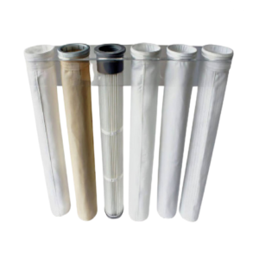
Arabo Filters designs and manufactures high-performance filter bags that form the core of every dust collection system. Whether for new installations or replacing bags in existing units, our solutions are custom-sized and locally produced, ensuring seamless fit, fast delivery, and unmatched quality. We offer a wide range of media—including Polyester, Polypropylene, PPS (Ryton®), Nomex® (Aramid), Acrylic, and Antistatic-treated fabrics—each engineered for optimal air permeability, tensile strength, and chemical resistance. Every bag is tailored to withstand your operating conditions, from 90°C to 240°C, and resist abrasion, moisture, acids, alkalis, and hydrolysis. With full vertical integration, Arabo delivers not just the collector—but the heart of it, built to last.
Markets/applications section
Food & Beverage, Fertilizers, Cement, metalurgical, mining.

Related Products:
Filter Cages – Filter Bags – Cartridge Dust Collector

