Arabo bag Cages collector
Arabo manufactures durable filter cages from electrostatic-painted steel or stainless steel, custom-built to match your dust collector’s size and bag type. Designed for structural strength and perfect fit, our cages ensure optimal airflow, efficient pulsing, and extended bag life.
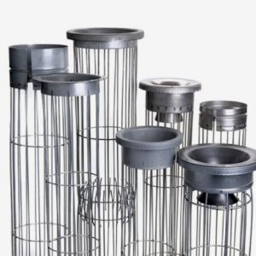
Properly engineered filter cages are essential for long-lasting and high-efficiency filtration. At Arabo Filters, we offer both standard and fully custom designs to match any baghouse system—circular, oval, or flat-panel configurations. Whether you’re retrofitting an existing collector or integrating into a new build, we ensure the perfect fit and performance.
Built to your specs
- Ring Diameters: 10mm~15mm
- Vertical wire counts: 10 Wires
- Horizontal ring spacing: 14mm~22mm between each ring

Materials & Finishes
- Materials: Electrostatic-painted steel or stainless steel
- Coatings: Epoxy, vinyl, zinc, and chrome finishes available for corrosion resistance and durability
Performance Benefits
- Ensures snug bag fit to avoid abrasion and premature wear
- Optimizes airflow and pulsing, supporting efficient dust removal
- Simplifies maintenance and bag removal, prolonging life span of filter media
Accessories Offered
- Compatible venturi inserts for pulse-jet optimization that are also customizable
- Leak-detection powders and tools for rapid troubleshooting

Markets/applications section
Food & Beverage, Fertilizers, Cement, metalurgical, mining.

Related Products:
Filter Cages – Filter Bags – Cartridge Dust Collector

