Arabo cartridge filters collector
Arabo Filters not only builds full dust collector systems; we also manufacture the essential components—filter bags and cages—from scratch. Whether you need new bags for a custom system or replacements for an existing setup, Arabo delivers tailor-made solutions precisely matched to your equipment and dust profile
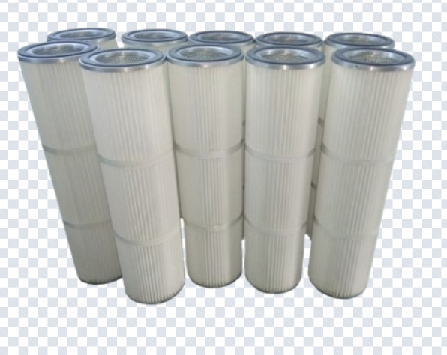
Technical Highlights & Benefits
○ Airflow capacity: From 3,000 to 50,000 m³/h, scalable to your operation
○ Filtration performance: Up to 200 m³ of air per m² of filter media
○ Efficiency: Over 99.9%, capturing even submicron dust
○ Filter media: Spunbonded with antistatic options
○ Design: Pleated cartridges for large surface area in minimal space
○ Cleaning system: Pulse-jet with PLC control for extended cartridge life

Markets/applications section
Food & Beverage, Fertilizers, Cement, metalurgical, mining.

Related Products:
Filter Cages – Filter Bags – Cartridge Dust Collector

