Arabo Baghouse dust collector

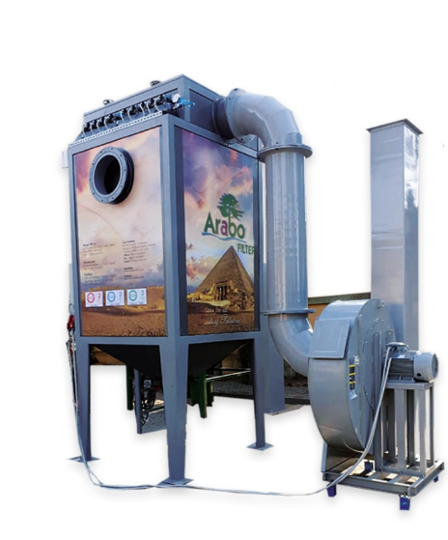
Baghouse Dust Collector
A high-efficiency, pulse-jet dust collection system designed to handle 3,000 to 50,000 m³/h airflow, capturing over 99% of fine dust across industries like cement, steel, food, and chemicals.

Why Arabo Filters?
Arabo manufactures the entire system in-house—from the dust collector body to its filter bags and cages. Every unit is custom-built to match your fan size, dust type, and space. Fast delivery, full quality control, and flexible designs set us apart.

Technical Highlights & Benefits
- Flow capacity: Models sized for 3,000 / 7,000 / 15,000 / 30,000 / 50,000 m³/h
- Filtration efficiency: Over 99%, including submicron particles
- Filter bags: Polyester, PP, Acrylic, or Nomex; sizes Ø130–160 mm, lengths up to 6 m
- Bag cages: Mild steel or stainless steel with reinforced top caps and venturis
- Pulse-jet cleaning: Compressed air system with PLC-controlled cycles

Filter Bags or Filter Cartridges?
Choose Bag Filters for:
- High dust loads and large air volumes
- Coarse or fibrous dust (e.g., cement, textiles)
- Chemical environments with aggressive or corrosive fumes
- Higher temperatures and rugged industrial settings
Choose Cartridge Filters for:
- Fine or light dust (e.g., welding, powder coating)
- Compact systems with limited space
- Cost:Airflow is more budget Friendly

Markets/applications section
Food & Beverage, Fertilizers, Cement, metalurgical, mining.

Related Products:
Filter Cages – Filter Bags – Cartridge Dust Collector

