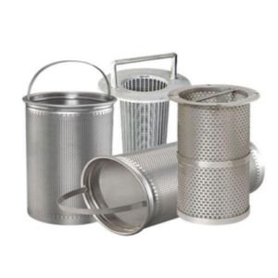
Basket Strainers (products)
Arabo Basket Strainers protect pipelines and equipment by capturing debris and particulates with high-capacity stainless steel baskets.
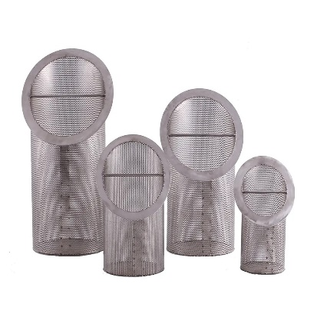
Arabo Basket Strainers are designed to capture and retain solid particles in liquid pipelines, protecting pumps, valves, and downstream equipment. They feature a durable body made from carbon steel, stainless steel 304, or 316, with a removable perforated or mesh-lined basket for easy cleaning and maintenance. Available in simplex or duplex configurations, Arabo Basket Strainers are ideal for water treatment, petrochemical, and general industrial applications requiring reliable coarse filtration.

Markets & Applications
Arabo Basket Strainers are used for coarse to medium liquid filtration in:
- Water treatment and cooling systems
- Petrochemical and chemical plants
- Food and beverage processing
- Pharmaceutical and cosmetics industries
- Pumps, nozzles, and instrumentation protection

Related Products: Pocket Bag Filter - Panel Pack Elements – Water Separator

