Arabo Baghouse dust collector

Cartridge Dust Collector
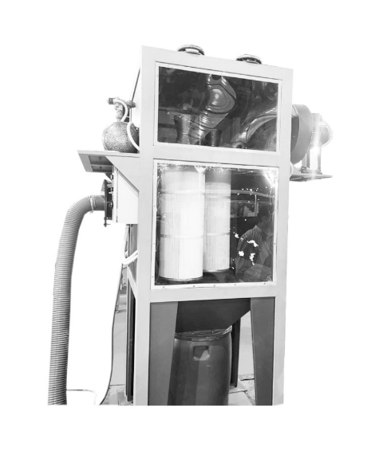
Compact, efficient, and built for precision, the Arabo Cartridge Dust Collector is ideal for fine dust applications in confined spaces. Designed with high-efficiency pleated filters and quick pulse-jet cleaning, it ensures long filter life, low pressure drop, and maximum airflow performance.

Why Arabo Filters?
Arabo manufactures precision-engineered cartridge dust collector systems in-house—from the housing to the high-efficiency filter cartridges. Every unit is custom-designed to fit your airflow, dust type, and space requirements. With fast turnaround times, advanced filtration media, and compact designs, Arabo ensures powerful performance with minimal footprint.

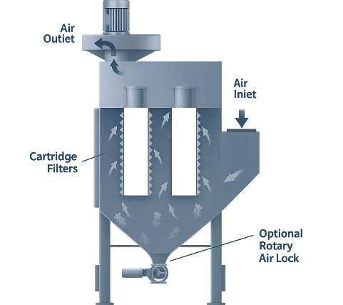
Technical Highlights & Benefits
○ Flow capacity: Models available from 3000 to 50,000 m³/h, optimized for fine dust control
○ Filtration efficiency: Over 99.9%, suitable for submicron particulate
○ Filter media: Spunbonded with Anti-Static Options
○ Filter sizes: Standard Ø325 mm (OD) x 660 mm / 1000 mm (L) pleated cartridges
○ Construction: Heavy-duty steel housing with quick-access doors for easy cartridge replacement
○ Pulse-jet cleaning: Integrated PLC-controlled system for efficient cleaning and extended filter life

Filter Bags or Filter Cartridges?
Choose Bag Filters for:
- High dust loads and large air volumes
- Coarse or fibrous dust (e.g., cement, textiles)
- Chemical environments with aggressive or corrosive fumes
- Higher temperatures and rugged industrial settings
Choose Cartridge Filters for:
- Fine or light dust (e.g., welding, powder coating)
- Compact systems with limited space
- Cost-to-Airflow is more budget Friendly

Markets/applications section
Food & Beverage, Fertilizers, Cement, metalurgical, mining.

Related Products:
Filter Cages – Filter Bags – Cartridge Dust Collector

