Extruded Screen Mesh
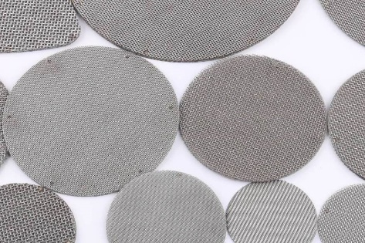
At arabo, we specialize in producing high-quality extruded screen mesh with fast delivery, customizability, and competitive pricing. Manufactured in a wide range of mesh sizes—including plain, twill, and Dutch weave—our screens adapt seamlessly to your filtration or extrusion system needs.
We engineer screens using 304 and 316 stainless steel, offering corrosion resistance and dimensional stability. Mesh counts range from 4 to 320, including Dutch weave styles like 110/24, 150/30, 325/2300, and 330/80 for enhanced strength and ultra-fine filtration down to 10 microns.
Our multi-layer packs are precision-welded, ensuring uniform flow, minimized pressure drop, and mechanical robustness. Wire diameter and thickness tolerances are tightly controlled (±0.01 mm), with aperture precision within ±2 µm, supporting exacting extrusion and melt-filtration demands.
Bullet Summary (Optional Use):
- Material: 304 & 316 Stainless Steel
- Mesh range: 4–320, including Dutch weave
- Micron rating: as fine as 10 µm
- Tolerance: ±2 µm aperture, ±0.01 mm thickness
- Configurations: single/multi-layer, spot-welded or framed
- Lead time: under 5 business days for custom sizes

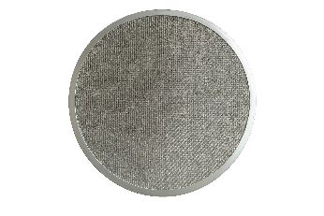
Markets/applications section
Refining

Related Products:
Mist Eliminator – Pall rings – Bubble Ca

