Fixed Valve tray

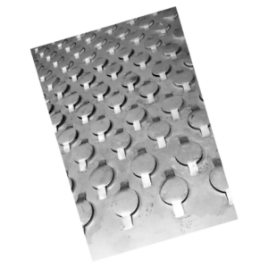
Arabo Filters Fixed Valve Tray is designed with precision-engineered fixed valves and a durable tray structure to deliver stable separation efficiency, high vapor handling capacity, and cost-effective operation in both new and retrofit column designs.
Fixed valve trays are widely used in distillation and absorption columns to enhance vapor–liquid interaction. With 3:1 to 5:1 turndown ratios and lateral vapor flow, they provide consistent mass transfer performance across a broad range of operating conditions.
Manufactured from 304/316L stainless steel or corrosion-resistant high alloys, Arabo’s fixed valve trays support vapor velocities up to 3.5 m/s, with 50–150 fixed valves per tray and orifice diameters ranging from 10–25 mm.
Available for column diameters from 600 mm to 6000 mm, these trays are ideal for demanding applications in the refining, petrochemical, and chemical processing industries.

Markets/applications section
Refining

Related Products:
Bubble cap tray – Pall rings – Regeneration Tray

