Oil Separator
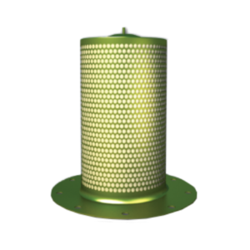
Arabo Oil Separator Filter uses high-surface pleated media to coalesce oil mist efficiently, safeguarding downstream compressed air systems with minimal pressure loss and extended operational reliability
Arabo Oil Separator Filter features deep-bed pleated borosilicate media that enhances surface area without enlarging the element, delivering oil residue levels as low as 2–3 ppm. Operating initially at ~0.1–0.2 bar pressure drops and rated for temperatures up to ~110 °C and collapse resistance up to 5 bar, this filter ensures superior oil removal and structural stability

Key Features & Advantages
- Deep-pleated borosilicate fiber media increases filtration surface for high capacity.
- Residual oil content down to 2–3 ppm makes it ideal for compressors and vacuum systems.
- Initial pressure drops as low as ~0.1–0.2 bar minimizes energy loss.
- Collapsible-resistant design rated to ~5 bar pressure resistance.
- Tested under high-specification standards (including ATEX-capable for hazardous atmospheres)

Markets / Applications
Ideal for compressed air or vacuum systems in:
- Industrial screw compressors (oil-lubricated)
- Vacuum pump systems (laboratory, medical, engineering)
- Manufacturing facilities requiring ultra-clean air
- Petrochemical and oil & gas processing units
- ATEX-rated installations in hazardous environments
Protects against downstream oil carryover, reduces maintenance, and preserves air quality.
RELATED PRODUCTS: Gas Turbine Filter – Filter Bags – Dust Collector Bags

