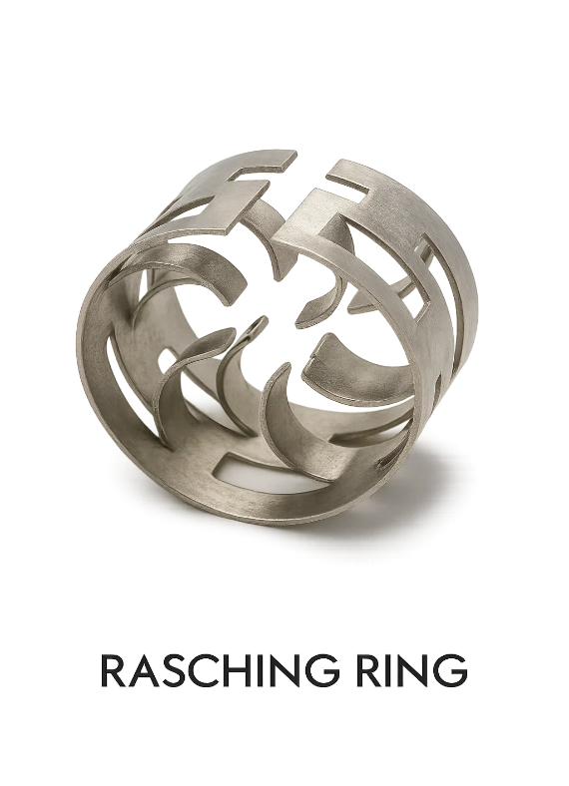
Rashing Ring/Pal Rings
25 mm Raschig rings deliver ~190 m²/m³ surface area at ~75% free volume, offering rugged and economical contact. Upgrading to 25 mm Pall rings gives ~206 m²/m³ with ~95% void for better performance at similar pressure drop. Available in SS 316/L or 304 grades.
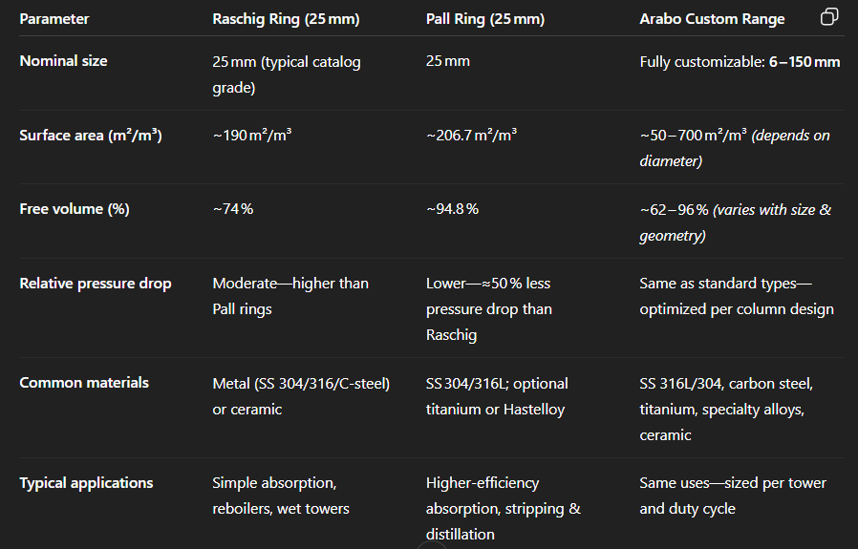
Arabo supplies steel and ceramic Raschig and Pall ring packings, custom-made in sizes from 6 mm to 150 mm. These offer compact mass-transfer advantages—high surface area, wide-open void volume, and low pressure drop—ideal for absorption, stripping, and distillation.

Markets/applications section : Refining

sDemister-- Valve Tray –Bubble Cap Tray
