Perforated Plate Structured Packing
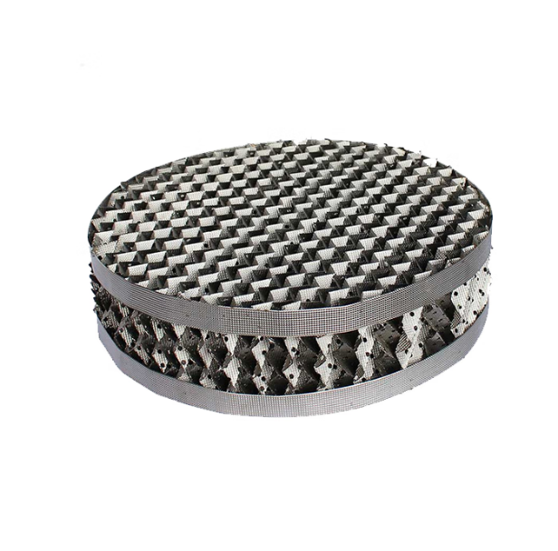
Arabo-filtered style: corrugated metal sheets punched with ~5 mm holes allow vapor-liquid flow in uniform channels. This setup creates a high surface-area, low pressure-drop structure with strong fouling and corrosion resistance—ideal for efficient distillation or absorption in large-scale industrial columns.
- High mass transfer efficiency
- Low pressure drops
- Easy to install and maintain
- Good corrosion resistance
- Strong anti-fouling ability
- Reduce gas flow pressure drop and low liquid holding capacity
- Strong absorption capacity
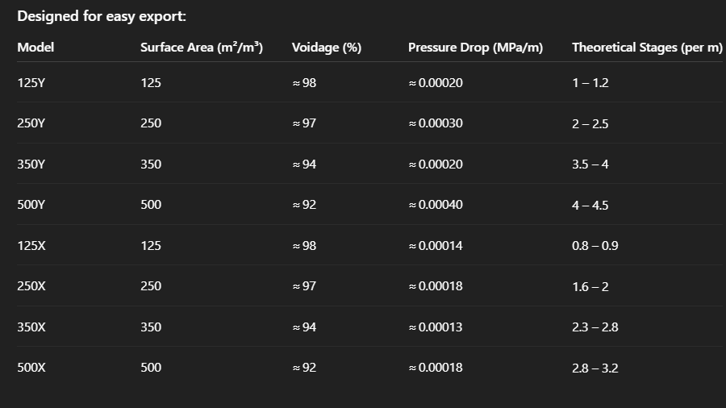
Thin corrugated metal sheets (~0.1–0.2 mm) are punched with ~5 mm round holes and stacked in alternating 30° (X-type) or 45° (Y-type) layers to form uniform flow paths. With surface area between 125–500 m²/m³, voidage of 92–98 %, and pressure drop around 0.00014–0.0003 MPa/m, this packing delivers superb mass transfer, high liquid capacity, and strong fouling resistance, suited for high-load separation

Related Product
Pall Ring- Wire Mesh-Demister

