Sieve tray
Arabo Filters Sieve Tray is a cost-effective and durable solution for distillation and absorption columns, offering efficient vapor–liquid contact through precisely punched holes and a mechanically robust design.
With no moving parts, sieve trays provide uniform vapor distribution and are ideal for processes with moderate flow variations, offering turndown ratios of 3:1 to 4:1.
Fabricated from 304/316L stainless steel or corrosion-resistant alloys, they handle vapor velocities up to 3.0 m/s, with hole sizes from 4–12 mm and open areas up to 15%. Suitable for 600 mm to 6000 mm columns in chemical, petrochemical, and gas processing industries.
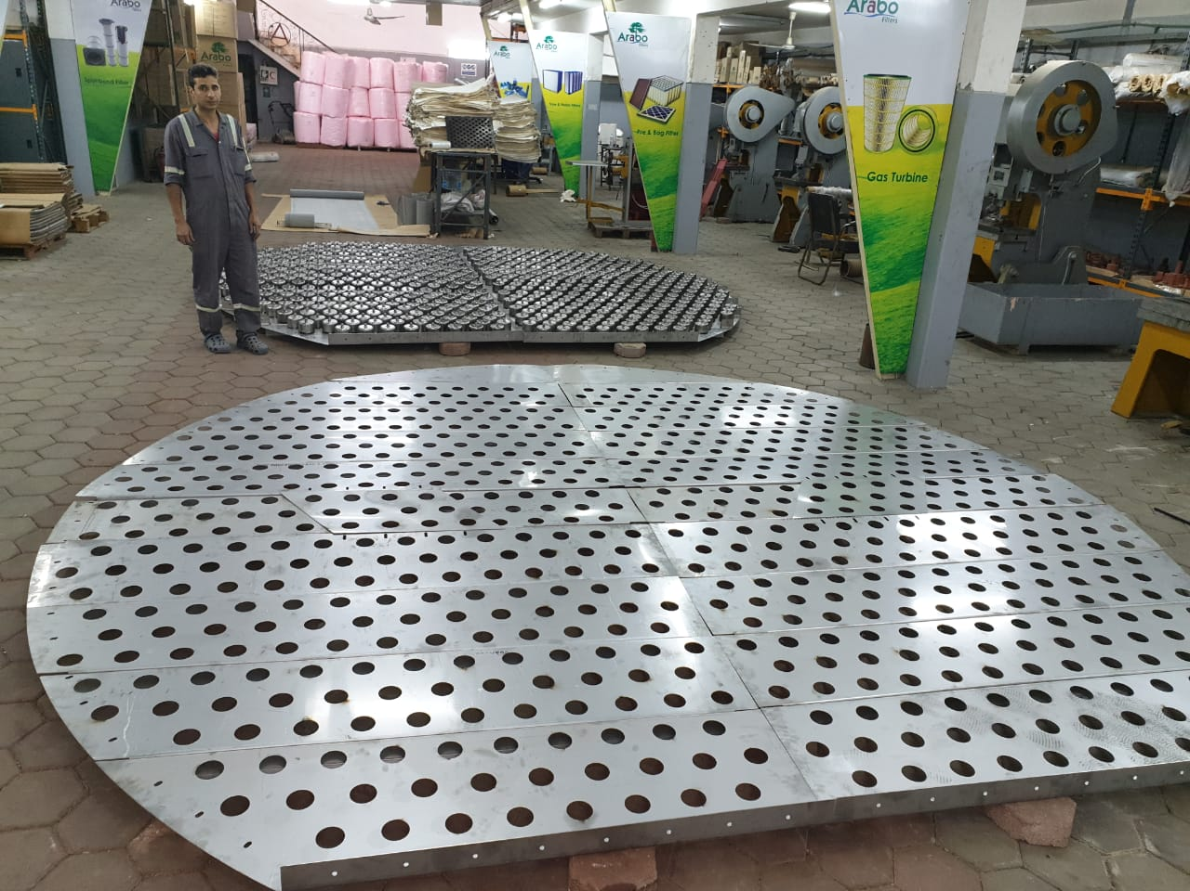

Markets/applications section
Refining

Related Products:
Bubble cap tray – Pall rings – Regeneration Tray

