Packing Support Grid
Arabo manufactures multi-beam packing support grids alongside pall rings, offering a full-package solution tailored to each project. Our products are fully customized and engineered to fit your process requirements precisely.
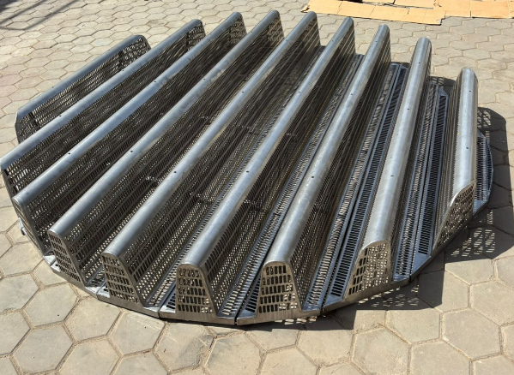
Our multi-beam packing supports are available in stainless steel 304 and 316, engineered to handle tower internals up to 100 °C (or higher per request) with low pressure drop designs. Each beam is precisely sized (typically ≈ 290 mm wide × 250–300 mm high) with openings under 10 mm to avoid packing migration. The design features separated gas and liquid paths to enhance mass-transfer efficiency, with sectional construction for ease of installation in columns up to 5m+ diameter.

- Materials: SS 304 or SS 316, optionally carbon steel or specialty alloys
- Beam width: ~290 mm, height range 250-300 mm per module
- Opening pitch: ≤ 10 mm, customizable patterns (slot, round, square)
- Open-area ratio: up to 100 %, ensuring minimal pressure drop (< 20 Pa)
- Load capacity: high stiffness for deep beds and dynamic liquid hold-up
- Modular/sectional design suited for man-way access and installation
- Compatible with ring and saddle type random packing, engineered for distillation, absorption and washing towers

Markets/applications section
Refining

Related Products:
Mist Eliminator – Pall rings – Bubble Cap Traym

