V bank Hepa Filter
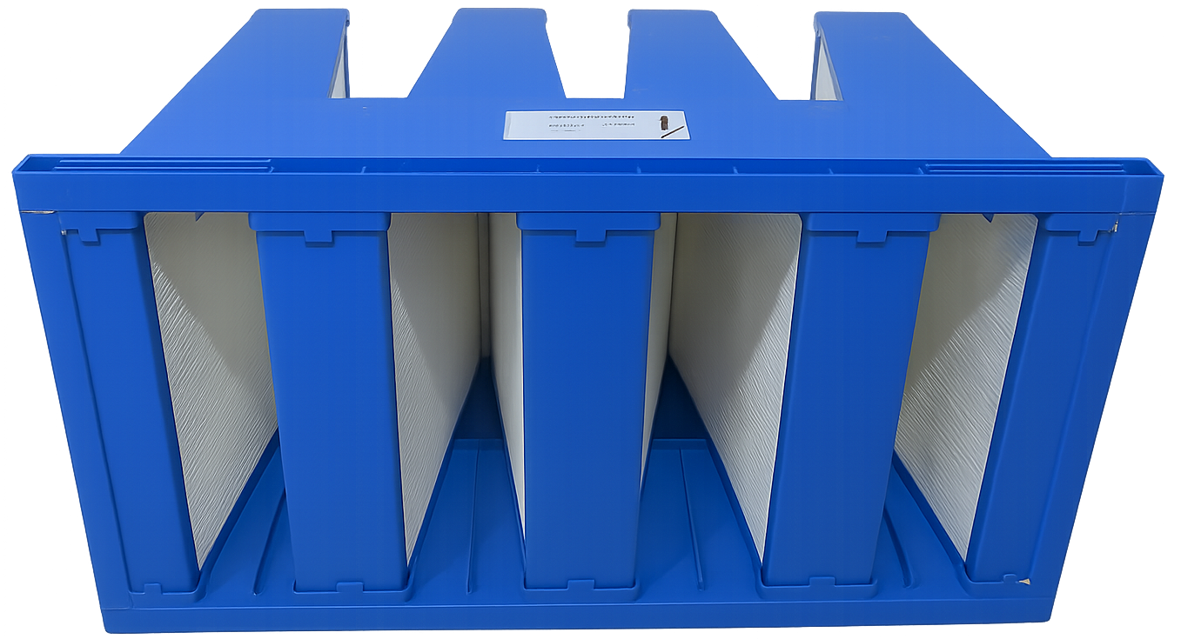
Manufactured, Tested, and tested at arabo filter’s new advanced production line, approved and certified according to EN-1822 & ISO-29463, Arabo’s V-bank Hepa Filter not only ensures optimal filtration and protection, but also maintains enhanced Airflow and filtration capacity, from E10~H14 (85%-99.995%).
Our V-Bank HEPA filters deliver efficiencies from E10 up to H14, ensuring removal rates between 85% and 99.995% for particles ≥0.3 µm. With high-surface pleated media and optimized low pressure drop, they support airflow up to 2400 cfm (~4,000 m³/hr), extending operational life while minimizing energy consumption.
- Designed per EN-1822 & ISO-29463 standards, factory-tested to guarantee ≥99.99% H14 performance.
- European imported materials all TAPPI tested and pleated at our factory, completely assembled by professionals all in a clean room to maintain its standard.
- Available frame depths: 2-5V, size from 592x592x292mm to custom dimensions, Plastic (PP) frame; operating temp up to 80 °C.
Frame: Aluminum, Galvanized Steel, Stainless steel, Plastic.
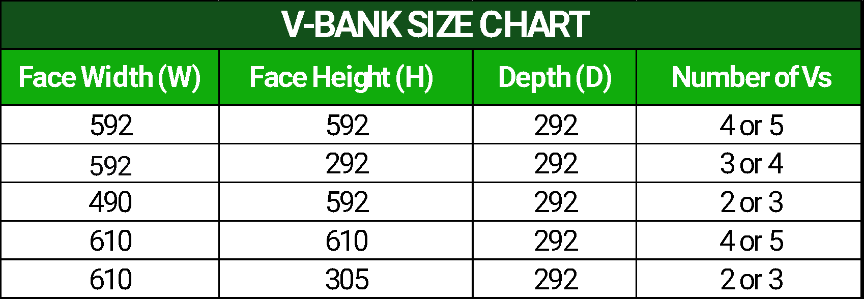

Markets/applications section
Oil & Gas // Petrochemical // Pharmaceutical // Food & Beverage // Water treatment
Related Products:
Cation Tank – Filter Housing– Hydraulic Filter

