Valve tray

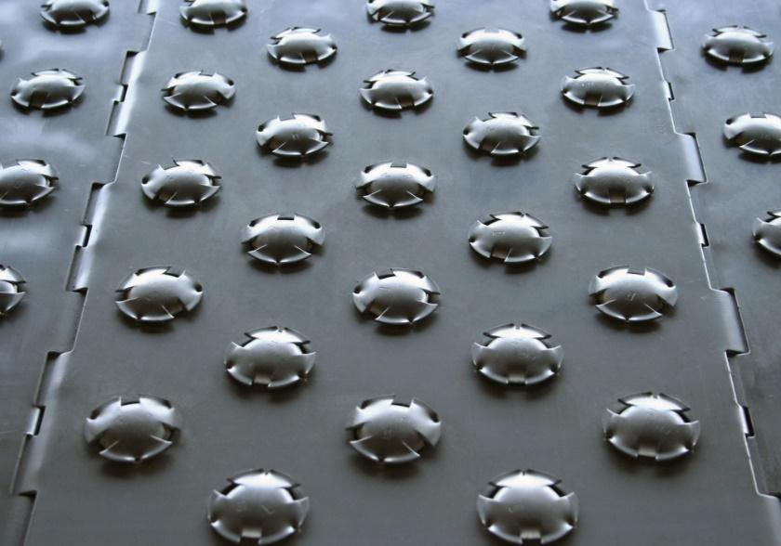
Arabo Filters Valve Tray is engineered with custom valve sizing and advanced tray design to deliver stable separation efficiency, high vapor throughput, and cost-effective performance in both new and revamp distillation columns
Valve trays are used in distillation and absorption columns to enhance vapor–liquid contact. With 3:1 to 5:1 turndown ratios and lateral vapor flow, they offer stable, efficient separation across a wide range of conditions.
Made from 304/316L stainless steel or high alloys, they support vapor loads up to 3.5 m/s, with 50–150 valves per tray and hole sizes from 10–25 mm. Suitable for 600 mm to 6000 mm columns in refining and petrochemical applications.

FAQ

Markets/applications section
Refining

Related Products:
Bubble cap tray – Pall rings – Regeneration Tray

