Water Separator
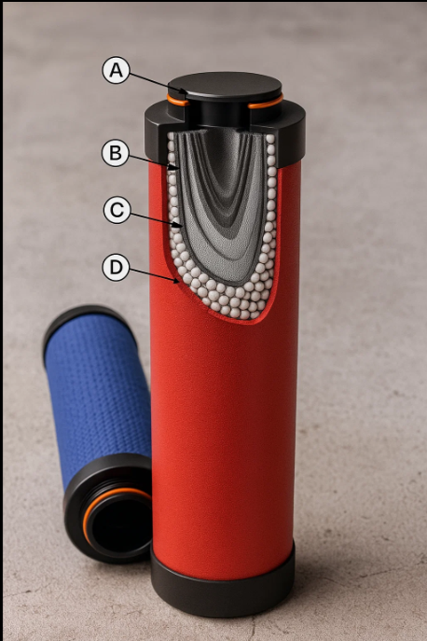
Arabo water separator blends six-layer microfiber glass coalescing and activated carbon adsorption within a stainless-steel, aluminum or polymer housing to eliminate aerosols, moisture, rust, oil and sub-micron particulates. Delivers dry, odor-free gas with minimal pressure drop in a compact, in-line configuration.
Six-layer glass-microfiber element rated 1–5 µm achieves ≥ 99.99999 % retention of droplets and particulates. Carbon-adsorbent stage removes oil vapor and odor. Installed in stainless, aluminum or polymer vessels rated to 16 bars. Integrated gravity or float drain, ΔP monitoring under 0.2 bar, modular cartridge design for rapid access and compact inline footprint.

Markets/applications section : water treatment / seperation/ Compressed Air Systems

Related Products: Oil Seperator/HVAC Filter/Air Filter
