Wire Gauze Structured Packing
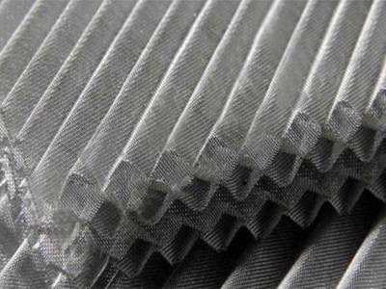
Arabo supplies wire gauze structured packing, made from woven metal mesh (e.g. SS 304, 316L), customizable and formed into corrugated sheets and stacked in alternating layers. This design enables precise gas–liquid contact—making it ideal for vacuum distillation, fine chemical separations, and temperature-sensitive processes

Technical & Performance Highlights
- Surface Area (Specific Contact Area):
Offered in multiple configurations to suit varying separation needs:
Greater surface area provides superior separation efficiency, especially in low-liquid load operations.
- Void Fraction:
With an open volume ranging between 85% and 95%, the packing allows for efficient gas-liquid contact while maintaining low flow resistance.
- Pressure Drop:
Extremely low pressure drops, typically between 10 and 67 Pa per layer, helping reduce energy consumption and maintain stable column operation.
- HETP (Height Equivalent to a Theoretical Plate):
Delivers excellent mass transfer efficiency with HETP values ranging from 100 mm to 400 mm, making it ideal for vacuum distillation, sensitive compounds, and high-purity separation processes.
Key Benefits:
- High mass transfer efficiency at low liquid loads

- Low pressure drops per theoretical stage

- High surface area with uniform void structure

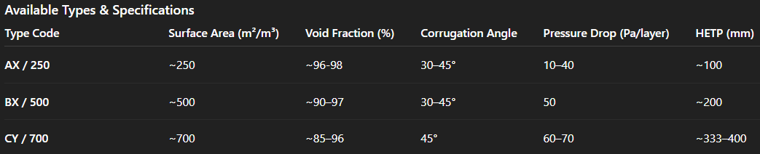
- Ideal for sensitive separations under vacuum conditions

Related Products: Wire Mesh Mist Eliminator – Liquid Distributer – Perforated Plate Structured Packing

